Homework 4

1. The relationship between the p_graph parameter and the maximum number of nodes in consensus (p_malicious = 0.1, p_txDistribution = 0.01, numRounds = 10)

|  |  |  |  |  |  |  |  |  |  |  |  |
| --- | --- | --- | --- | --- | --- | --- | --- | --- | --- | --- | --- |
| p_graph | 1 | 2 | 3 | 4 | 5 | 6 | 7 | 8 | 9 | 10 | average |
| **0.1** | 92 | 91 | 88 | 85 | 86 | 92 | 90 | 90 | 93 | 83 | **89** |
| **0.2** | 89 | 97 | 92 | 91 | 87 | 87 | 86 | 91 | 83 | 92 | **89.5** |
| **0.3** | 88 | 89 | 90 | 94 | 90 | 87 | 88 | 94 | 90 | 90 | **90** |
| **0.4** | 91 | 93 | 91 | 87 | 91 | 87 | 92 | 90 | 91 | 89 | **90.2** |
| **0.5** | 94 | 89 | 92 | 88 | 95 | 89 | 89 | 86 | 89 | 94 | **90.5** |

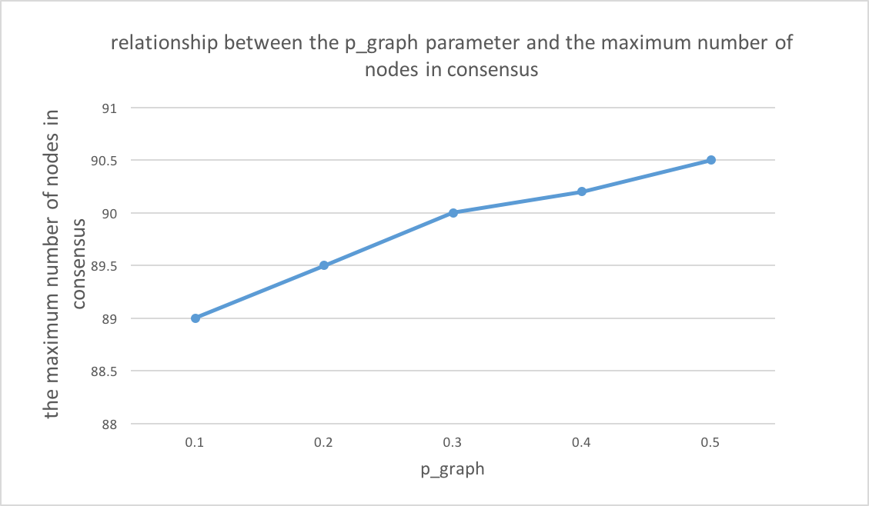

According to the above line graph, when p_graph parameter increases, the maximum number of nodes in consensus have little change, the number remains between 89~92. The effect of p_gragh is very unobvious, even no effect on the number of nodes in consensus.

1. The relationship between the p_malicious parameter and the maximum number of nodes in consensus (p_graph = 0.1, p_txDistribution = 0.01, numRounds = 10)

|  |  |  |  |  |  |  |  |  |  |  |  |
| --- | --- | --- | --- | --- | --- | --- | --- | --- | --- | --- | --- |
| p_malicious | 1 | 2 | 3 | 4 | 5 | 6 | 7 | 8 | 9 | 10 | average |
| **0.15** | 86 | 85 | 85 | 94 | 84 | 81 | 74 | 71 | 52 | 81 | **79.3** |
| **0.3** | 49 | 48 | 57 | 26 | 51 | 47 | 33 | 49 | 56 | 37 | **45.3** |
| **0.45** | 21 | 6 | 7 | 22 | 6 | 22 | 2 | 8 | 6 | 10 | **11** |
| **0.6** | 1 | 1 | 2 | 2 | 1 | 1 | 1 | 1 | 1 | 1 | **1.2** |
| **0.75** | 1 | 1 | 3 | 1 | 1 | 1 | 1 | 1 | 1 | 1 | **1.2** |

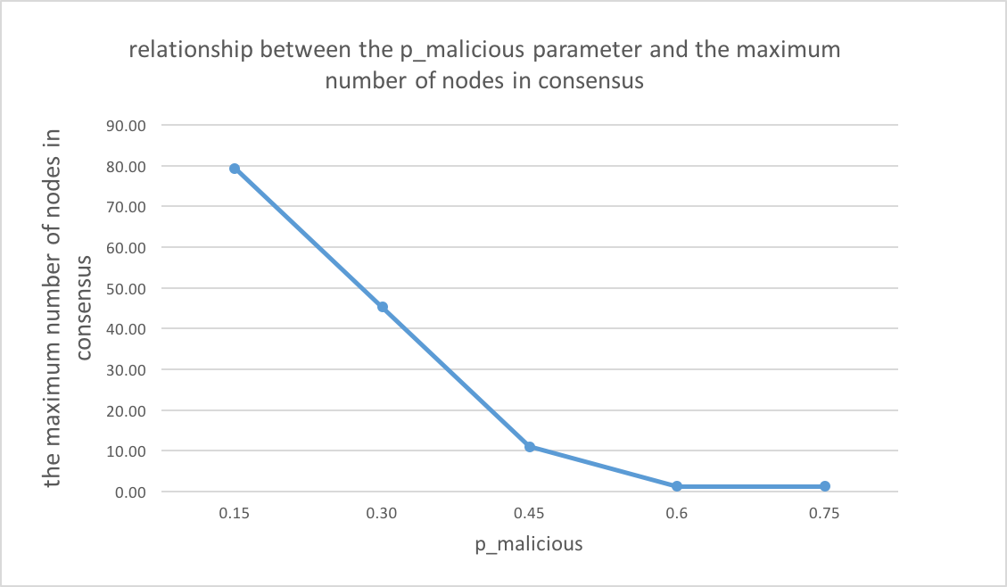

According to the above line graph, when p_malicious parameter increases, the percentage of malicious nodes will increase; consequently, the maximum number of nodes in consensus will decrease. The effect is significant.

1. The relationship between the p_txDistribution parameter and the maximum number of nodes in consensus (p_graph = 0.1, p_malicious = 0.1, numRounds = 10)

|  |  |  |  |  |  |  |  |  |  |  |  |
| --- | --- | --- | --- | --- | --- | --- | --- | --- | --- | --- | --- |
| p_txDistribution | 1 | 2 | 3 | 4 | 5 | 6 | 7 | 8 | 9 | 10 | average |
| **0.01** | 88 | 82 | 86 | 93 | 90 | 86 | 92 | 87 | 88 | 93 | **88.5** |
| **0.05** | 86 | 95 | 83 | 84 | 91 | 86 | 93 | 92 | 91 | 90 | **89.1** |
| **0.1** | 89 | 93 | 92 | 91 | 92 | 89 | 87 | 91 | 91 | 90 | **90.5** |
| **0.15** | 88 | 95 | 95 | 89 | 87 | 89 | 92 | 89 | 89 | 88 | **90.1** |
| **0.2** | 89 | 85 | 81 | 89 | 89 | 94 | 95 | 91 | 95 | 89 | **89.7** |

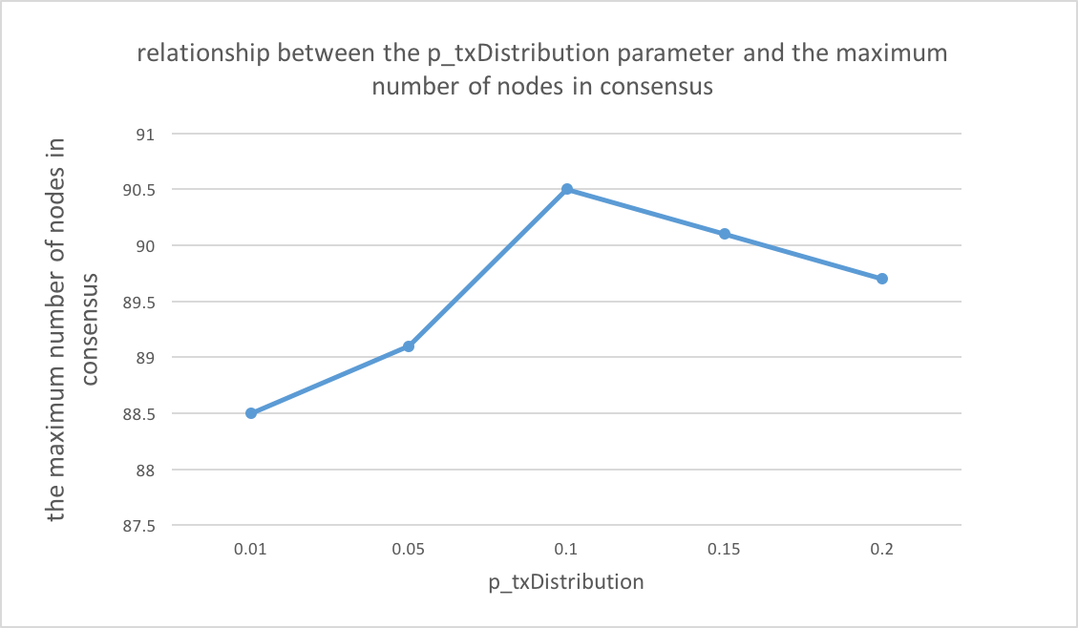

According to the above line graph, p_txDistribution parameter has no effect on the maximum number of nodes in consensus. When the parameter increase, the random selections of transactions increase. However, this change doesn’t affect on the number of nodes in consensus.

1. The relationship between the numRounds parameter and the maximum number of nodes in consensus (p_graph = 0.1, p_malicious = 0.1, p_txDistribution = 0.01)

|  |  |  |  |  |  |  |  |  |  |  |  |
| --- | --- | --- | --- | --- | --- | --- | --- | --- | --- | --- | --- |
| numRounds | 1 | 2 | 3 | 4 | 5 | 6 | 7 | 8 | 9 | 10 | average |
| **10** | 89 | 96 | 84 | 85 | 90 | 91 | 88 | 82 | 87 | 92 | **88.4** |
| **20** | 91 | 80 | 85 | 84 | 81 | 91 | 92 | 87 | 84 | 84 | **85.9** |
| **30** | 81 | 90 | 85 | 93 | 88 | 82 | 76 | 88 | 96 | 79 | **85.8** |
| **40** | 89 | 86 | 93 | 89 | 90 | 91 | 88 | 89 | 83 | 86 | **88.4** |
| **50** | 88 | 90 | 91 | 73 | 78 | 87 | 91 | 90 | 88 | 90 | **86.6** |

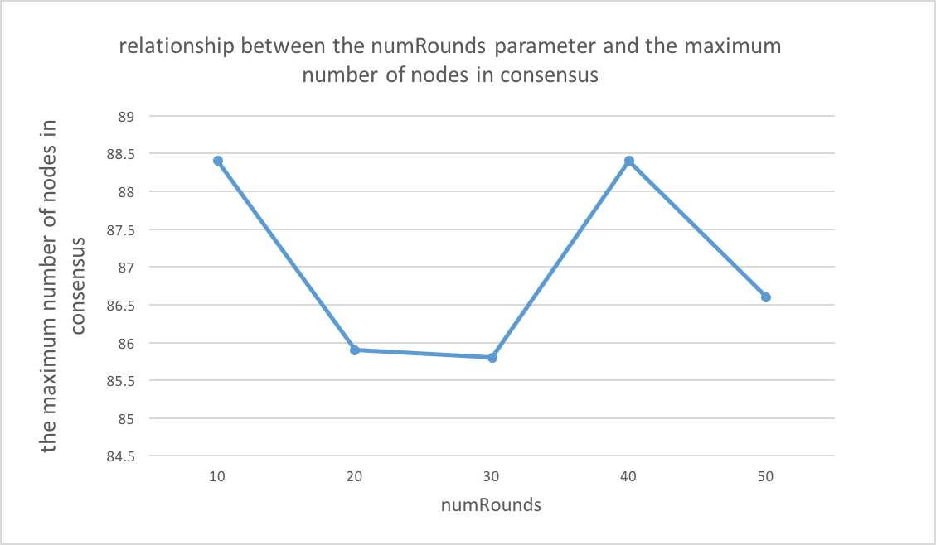

According to the above line graph, numRounds parameter has no effect on the maximum number of nodes in consensus.